SD6: Data download instructions:
- Navigate to the ACCT-CTTI website: https://aact.ctti-clinicaltrials.org/download

- Click the “Pipe-Delimited Files” tab.
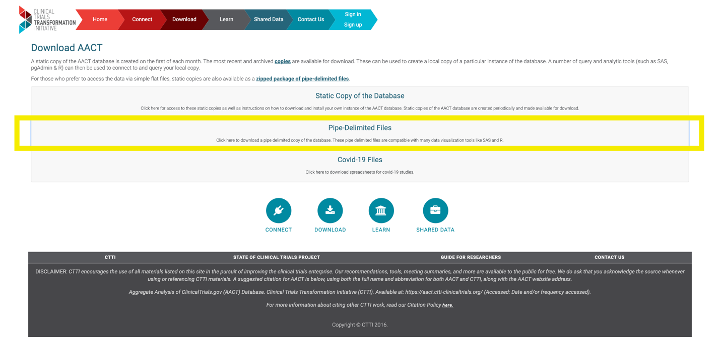

- From the “Monthly Archive of Static Copies” drop down menu, select 20230822_export.zip file. A zip file should download automatically.

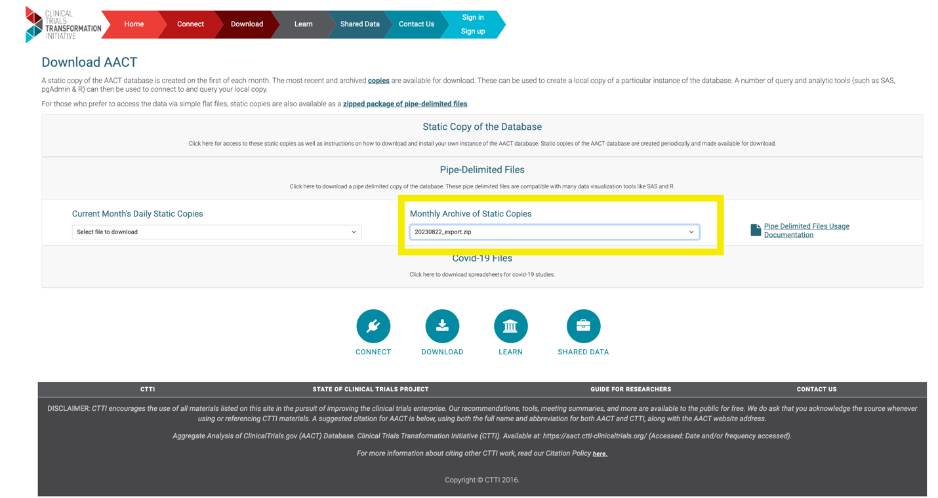
- Unzip the folder and navigate to the “conditions.txt” file to access the conditions names used in each clinical trial.

